Siri and Cortana
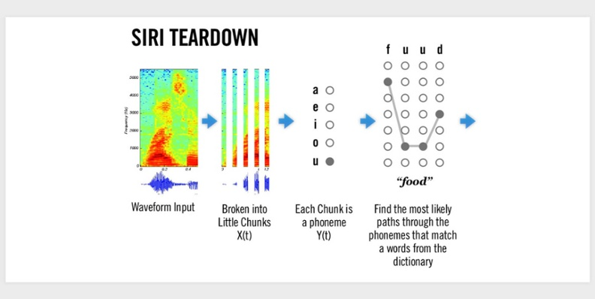
Voice recognition systems such as Siri and Cortana use machine learning and deep neural networks to imitate human interaction. As they progress, these apps will learn to ‘understand’ the nuances and semantics of our language.
For example, Siri can identify the trigger phrase ‘Hey Siri’ under almost any condition through the use of probability distributions. By selecting appropriate speech segments from a recorded database, the software can then choose responses that closely resemble real-life conversation.

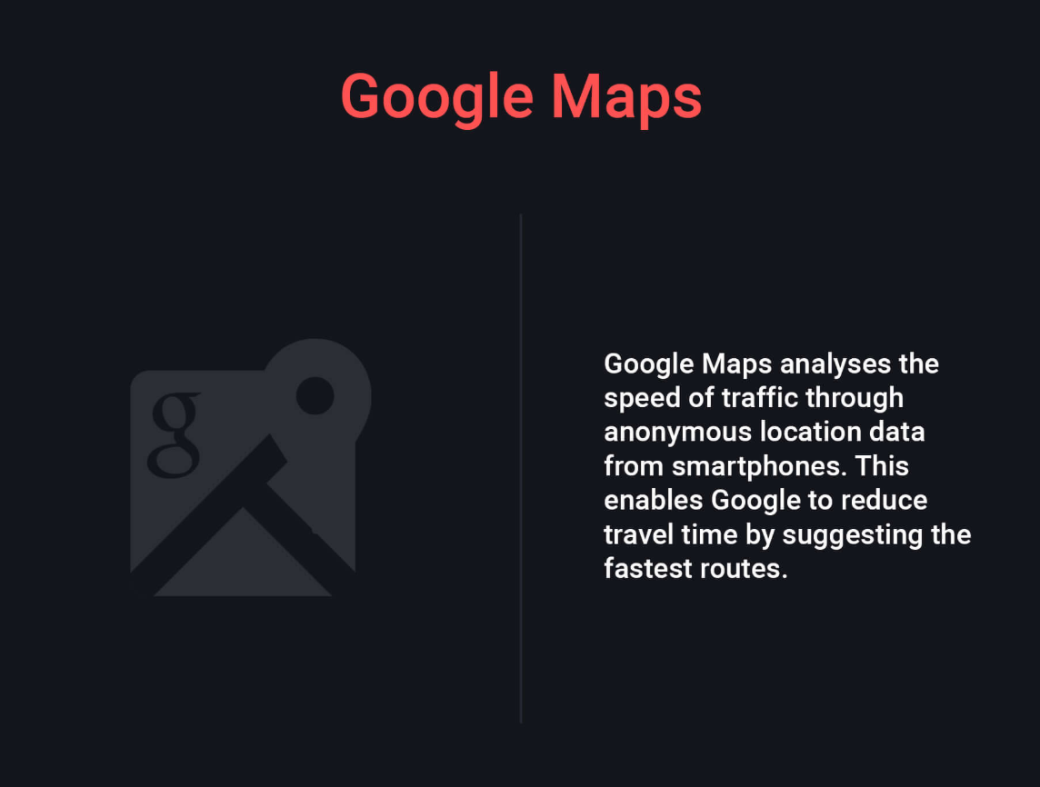






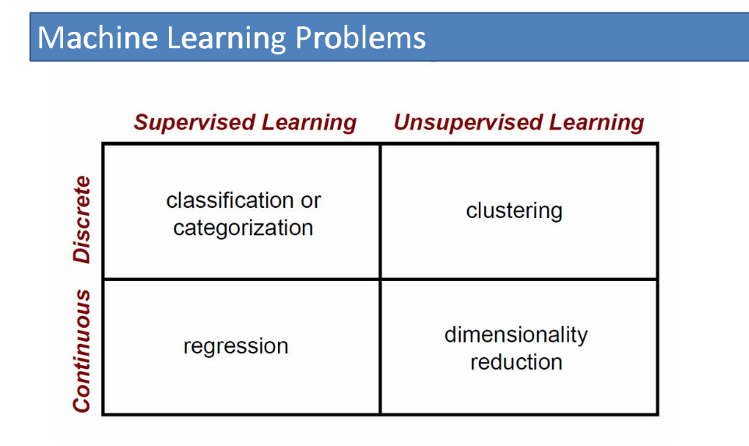
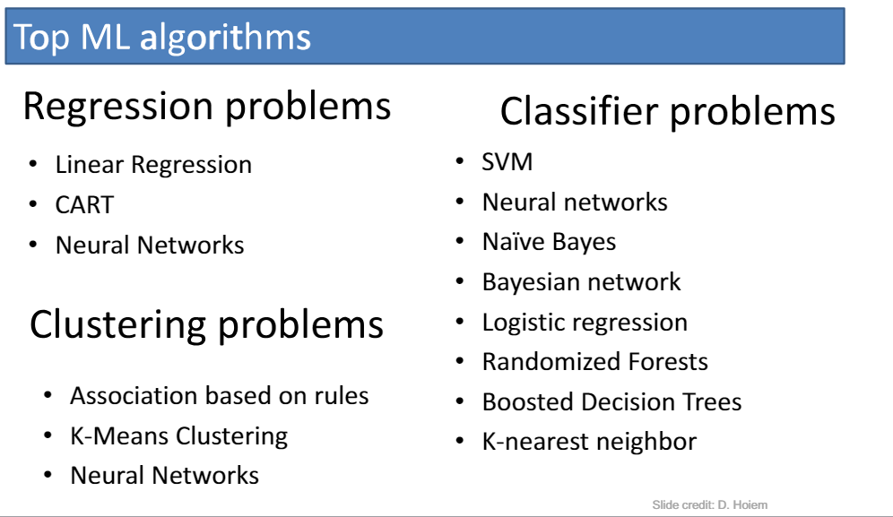



How do I learn coding in a single night?
Well learning coding requires time and practice.
But as you asked you want to learn it in single night.. so i would suggest you to move to countries like Norway, Sweden, Finland and places like Alaska and North Canada which experience 6 months of daytime during summer (and 6 months of darkness during winters).

